CTM-I Test Plan

Menu Tab: Firm Maintenance

Screen: Firm Statistics

Version 0.1

Menu Tab: Firm Maintenance

Use Case Name | Firm Statistics
User Roles | CBOE Firm (CTMI_Firm_Options_Clerk), Market Ops (CTMI_Help_Desk), Ops (CTMI_Form_options_Root), App Support (CTMI_Root)
Pre-conditions /Assumptions | User has successfully logged into the CTM-I application.
Post Conditions | None
Screenshot | 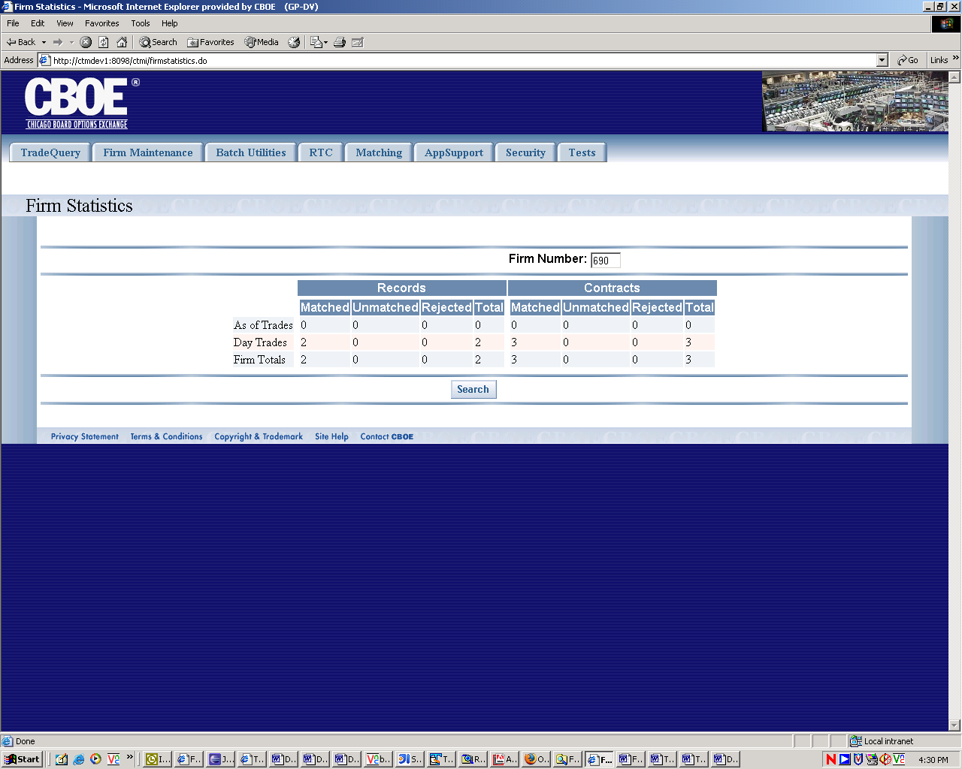
Test Scenario A | User Role : CTMI_Firm_Options_Clerk, User Id: xxx Password: xxx
 | Action | Expected Out Come | Comments/Results
Test Case 1  Display Firm Statistics Screen | User clicks on Firm Statistics Menu | Firm Statistics screen displays As of Trades, Day Trades and Firm Totals for the Primary Firm. Firm Number Field is drop down box populated with Primary firm and authorized Firms.
Test Case 2  Search | User Selects Firm Number in the named field and clicks Search button. | Screen Displays firms statistics on two column blocks namely Records and Contracts | If no matching firms exist no rows are returned.  All rows are returned on the same page. May have to scroll down for large amount of data rows.
 | User Enters Invalid Firm (Non-Numeric and more than 3 digits) number on the search field and clicks ‘Search’. | Error Message Invalid Firm Error Message would appear. | Alternate Flow
 | User Enters nothing in the Firm Field and clicks ‘Search’ | Screen should display error message on screen –No Firm entered. | Alternate Flow
Test Scenario B | Repeat above test cases with login with diff user roles namely Ops (CTMI_Firm_Options_Root)  User Id: xxx Password: xxx
 | Same As Scenario A
Test Scenario C | Repeat above test cases with login with diff user roles namely AppSupport (CTMI_Root)  User Id: xxx Password: xxx
 | User clicks on Firm Statistics Menu | Firm Statistics screen displays As of Trades, Day Trades and Firm Totals for the Primary Firm. Firm Number Field is text box populated with 000.
 | Remaining Same As Scenario A
Test Scenario D | Repeat above test cases with login with diff user roles namely Market Ops (CTMI_Help_Desk),  User Id: xxx Password: xxx
 | Same As Scenario C

